**COMP 4190 Assignment 2: Bayesian Networks**

**Submitters:** Arsh Khokhar (7833350), Kiernan Wiese (7813635)

**2-a: Bayes Network to identify fraudulent transactions**

|  |  |  |  |
| --- | --- | --- | --- |
| **Trav** | **Fraud** | **FP** | **P(FP | Trav, Fraud)** |
| +trav | +fraud | +fp | 0.9 |
| +trav | +fraud | -fp | 0.1 |
| +trav | -fraud | +fp | 0.9 |
| +trav | -fraud | -fp | 0.1 |
| -trav | +fraud | +fp | 0.1 |
| -trav | +fraud | -fp | 0.9 |
| -trav | -fraud | +fp | 0.01 |
| -trav | -fraud | -fp | 0.99 |

|  |  |
| --- | --- |
| **Trav** | **P(Trav)** |
| +trav | 0.05 |
| -trav | 0.95 |

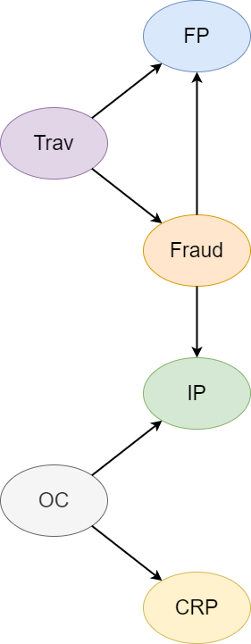

|  |  |  |
| --- | --- | --- |
| **Trav** | **Fraud** | **P(Fraud | Trav)** |
| +trav | +fraud | 0.01 |
| +trav | -fraud | 0.99 |
| -trav | +fraud | 0.004 |
| -trav | -fraud | 0.996 |

|  |  |
| --- | --- |
| **OC** | **P(OC)** |
| +oc | 0.7 |
| -oc | 0.3 |

|  |  |  |  |
| --- | --- | --- | --- |
| **OC** | **Fraud** | **IP** | **P(IP | OC, Fraud)** |
| +oc | +fraud | +ip | 0.02 |
| +oc | +fraud | -ip | 0.98 |
| +oc | -fraud | +ip | 0.01 |
| +oc | -fraud | -ip | 0.99 |
| -oc | +fraud | +ip | 0.011 |
| -oc | +fraud | -ip | 0.989 |
| -oc | -fraud | +ip | 0.001 |
| -oc | -fraud | -ip | 0.999 |

|  |  |  |
| --- | --- | --- |
| **OC** | **CRP** | **P(CRP | OC)** |
| +oc | +crp | 0.1 |
| +oc | -crp | 0.9 |
| -oc | +crp | 0.001 |
| -oc | -crp | 0.999 |

**2-b: Answering queries by using the variable elimination code**

* Prior Probability that the current transaction is Fraud

**Query:** P(Fraud)

**Output generated by the code:**



* Probability that the current transaction is fraud once we verify that it is a foreign transaction, but not an internet purchase and that the card holder purchased computer related accessories in the past week

**Query:** P(Fraud |+fp, -ip, +crp)

**Output generated by the code**

